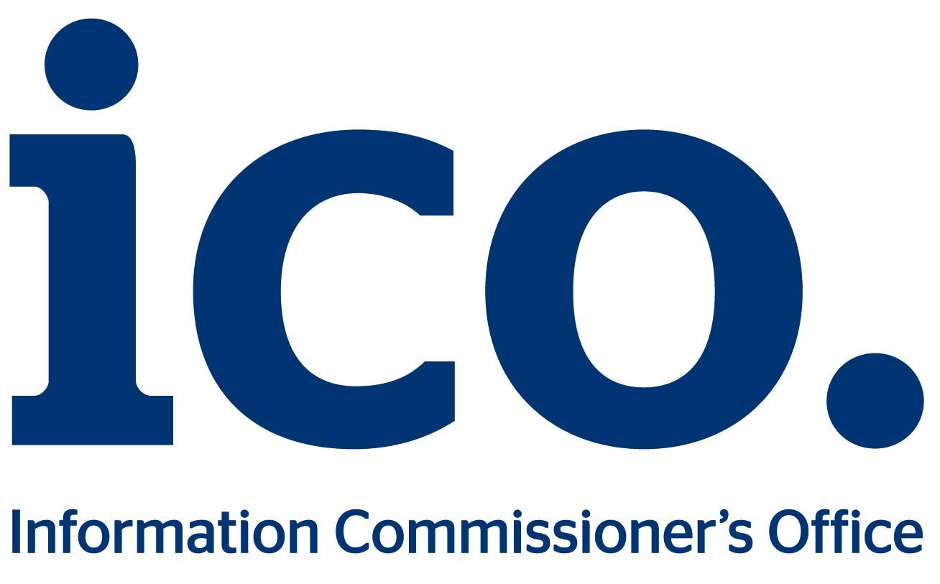
Information Commissioner’s Office

Consultation
‘A clear course for changing times’
The ICO Plan 2015-18

Start date: Monday 2 February2015
End date: Friday 27 February 2015

Introduction

The ICO has a three year rolling plan which details how we intend to achieve our six objectives:

- Organisations have a better understanding of their information rights obligations.
- Enforcement powers are used proportionately to ensure improved information rights compliance.
- Customers receive a proportionate, fair and efficient response to their information rights concerns.
- Individuals are empowered to use their information rights.
- The ICO is alert and responsive to changes which impact on information rights.
- An efficient ICO, well prepared for the future.

We have updated the plan for the period from April 2015 to March 2018, taking into account emerging priorities. There are uncertainties; there will be a new Parliament in May, we are expecting the findings of the recent Triennial Review of the ICO before April, and the new EU data protection regulation is likely to have a significant impact on our work within the period of the Plan. We will therefore review the Plan and revise it where necessary.

However, before finalising the Plan for the start of April we are interested in hearing the views of organisations, individuals and ICO staff.

Responses to this consultation must be submitted by close Friday 27 February 2015.

You can submit your response in one of the following ways:

Complete this document and either email it to consultations@ico.org.uk

or print it and post to:
Corporate Governance
Information Commissioner’s Office
Wycliffe House
Water Lane
Wilmslow
Cheshire
SK9 5AF
Privacy statement

Following the end of the consultation we shall publish a summary of responses received. Information provided in response to our consultations, including personal information, may be disclosed in accordance with the Freedom of Information Act 2000 and the Data Protection Act 1998. If you want the information that you provide to be treated as confidential please tell us, but be aware that we cannot guarantee confidentiality.

Further information

If you would like further information on the consultation please telephone Peter Bloomfield on 01625 545 746 or email consultations@ico.org.uk.

Your views (please mark the appropriate box and field)

- Does the ICO Plan clearly detail what the ICO intends to do over the next three years?

☐ | Yes
☐ | No  Please explain why not:

- Do you think that what the ICO plans to do will help the ICO achieve its six objectives?

☐ | Yes
☐ | No  Please explain why not:

- Is there anything specific that you would like us to do which is not in the Plan?

☐ | Yes  Please explain what:
☐ | No

- Is there anything in the Plan which you think we should not be doing?
☐ | Yes  Please explain what:
☐ | No

- Please provide any further comments or suggestions on our draft Plan.

Section 2: About you

Are you:

A member of the public who has used our service? | Y/N
A member of the public who has not used our service? | Y/N
A representative of a public sector organisation?  Please specify: | Y/N
A representative of a private sector organisation?  Please specify: | Y/N
A representative of a community, voluntary or charitable organisation, or of a trade body?  Please specify: | Y/N
An ICO employee? | Y/N
Other?  Please specify: | Y/N

Thank you for completing this consultation.
We value your input.

