ICO strategy consultation: Freedom of Information and Environmental Information
The Information Commissioner is seeking feedback on her draft strategy: Openness by design - 2019 to 2022. The draft strategy sets out the Information Commissioner’s goals for the regulation of the Freedom of Information Act (FOIA) 2000, the Environmental Information Regulations (EIR) 2004 and the Reuse of Public Sector Information Regulation 2015.
The strategy is now out for public consultation and will remain open until Friday 8 March 2019. The Information Commissioner welcomes feedback on any aspect of the strategy. Alternatively, you might also want to consider the specific questions set out below.
Please send us your comments by 8 March 2019.
Privacy statement
For this consultation we will publish responses received from organisations but will remove any personal data before publication. We will not publish responses from individuals. For more information about what we do with personal data please see our privacy notice.
Please note that we are using the platform Snap Surveys to gather this information. Any data collected by Snap Surveys for ICO is stored on UK servers. You can read their Privacy Policy here.
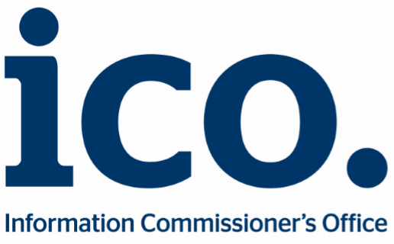
Do you agree with the vision we have set out for the regulation of access to information rights?

What if anything would you like to change in the proposed vision?

Do you agree with our five proposed goals?
What, if anything, would you like to change about the goals?

Strategic Priorities
Looking at the strategic priorities under each of the five goals, are there any areas of work that you think are more important than others?
Please rank them from 1-6 with 1 being the most important and 6 being the least important. Please explain the reasons for your answers.
Goal #1 Improve standards of accountability, openness and transparency in a digital age
Develop, pilot and roll out a self-assessment toolkit for public authorities to support them in making improvements to information handling practice and openness.
Build on our initial learning from Data Protection Impact Assessments and asses the feasibility of ‘openness’ or ‘transparency’ impact assessments and audits offered as an advisory service provided by the Information Commissioner’s Office.
Increase the impact of FOIA enforcement activity through targeting of systemic non-compliance, consistent with the approaches set out in our Regulatory Action Policy .

Working in partnership with technology experts, FOIA practitioners and stakeholders we will scope and publish a technology review to shine a light on how public authorities are using technology in relation to searches for information.
Working in partnership with public authorities and civil society organisations, research and promote new digital approaches to proactive disclosure of information, including making the most of open data opportunities.

Use insight from our casework and intelligence from the external environment to scope and publish a series of thematic reports and own- motion studies that make recommendations for change to drive improvements in understanding, accountability, openness and transparency.

Goal #2 Provide excellent customer service in our independent review services for the public and public authorities
Devise, pilot and roll-out a programme of customer feedback.

Use the feedback to inform the development of a new service charter setting out expectations for the public and public authorities.

Review and implement improvements to our core processes and systems to meet customer needs and improve the efficiency and quality of the services we provide.

Review and develop new guidance consistent with our Regulatory Action Policy, prioritising those areas of greatest impact and promoting external guidance alongside the publication of our Decision Notices.

Goal #3 Raise awareness of access to information rights and make them more accessible
Drawing on the learning from the recent ICO ‘Your data matters’ campaign, we will develop, deliver and evaluate a series of targeted information rights campaigns to raise awareness of FOIA and EIR rights and show how access to information makes a difference.

Develop new engagement channels to promote guidance, support and good practice for public authorities including the organisation of practitioner workshops.
Review and refine our policies, processes and systems to make it easy for people to bring their cases to us and for public authorities to comply with the requirements of the law.

Goal #4 Promote the reform of information rights legislation so it remains fit for purpose
Continue to build and promote the case for changes to the scope of FOIA andEIR legislation working closely with colleagues in government and Parliament, public authorities, the private sector, civil society organisations, the media and the public.

Engage and consult with our stakeholders to review other potential areas for legislative change.

Work with other regulators and The National Archives to explore the practical application of duty to document frameworks.

Goal #5 Develop and sustain new international partnerships
Promote standards of openness and transparency globally and aim to embed good practice by providing the secretariat for the International Conference of Information Commissioners.

Work in partnership with UNESCO and international colleagues to contribute towards promotion of information rights as part of the achievement of the United Nations Sustainable Development Goals framework.
Continue to promote access to information rights as part of the wider work of the Open Government Partnership.

What impact do you think our proposals will have on equality and human rights?
Are there any other points you want to make about the proposals in this document?

About you
Are you answering these questions as:

