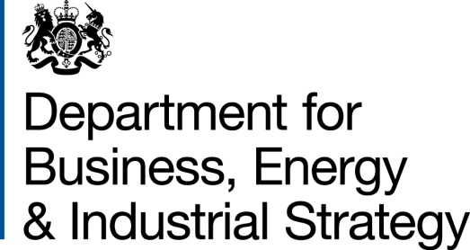
BUSINESS IMPACT TARGET:
SUMMARY TEMPLATE
Non-qualifying Regulatory Provisions (NQRP) summary reporting template

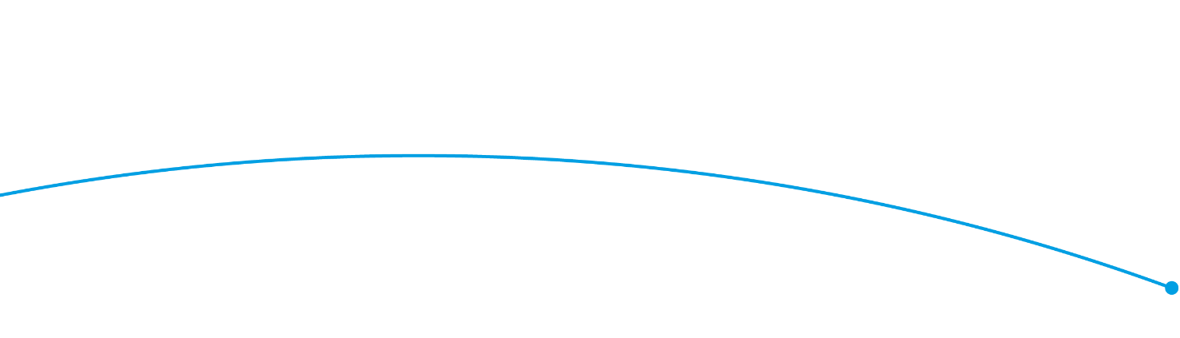

Regulator: Information Commissioner’s Office (ICO)
Business Impact Target Reporting Period Covered: 13 December 2019 to 16 December 2020
Excluded Category* | Summary of measure(s), including any impact data where available**
Measures certified as being below de minimis (measures with an EANDCB below +/- £5 million) | Following consideration of the exclusion category there are no measures for the reporting period that qualify for the exclusion.
EU Regulations, Decisions and Directives and other international obligations, including the implementation of the EU Withdrawal Bill and EU Withdrawal Agreement | Launch of “Age Appropriate Design; a code of practice for on-line services” to support compliance with the Data Protection Act 2018 (DPA) and the General Data Protection Regulation (GDPR) - estimated one-off cost to business £60m.  The code is risk based, which means it does not apply to all organisations in the same way.
Measures certified as concerning EU Withdrawal Bill operability measures | Following consideration of the exclusion category there are no measures for the reporting period that qualify for the exclusion.  However, the ICO’s Business Services set up a new dedicated helpline for organisations with specific queries about EU withdrawal. They produced a suite of guidance and resources to help organisations prepare for the end of the transition period on the ICO’s website.
Pro-competition | The ICO, Competition and Markets Authority, and Ofcom have set up a forum to help ensure online services work well for consumers and businesses in the UK. The Digital Regulation Cooperation Forum strengthens existing collaboration between the regulators and aims to harness expertise when data, privacy, competition, communications and content interact.  Based on feedback the ICO has redeveloped its SME web hub to make it as easy as possible for SMEs to find, understand and act on our advice. Fourteen new easy-to-follow blogs and guides, and dozens of new FAQs have been added to complement the existing SME helpline and live chat services. The ICO has responded to 170,000 organisations most of which are SMEs.
Systemic Financial Risk | Following consideration of the exclusion category there are no measures for the reporting period that qualify for the exclusion.
Civil Emergencies | Following consideration of the exclusion category there are no measures for the reporting period that qualify for the exclusion.
Fines and Penalties | The total amount of fines issued to non-public sector organisations for not registering with the ICO was £145,000.  Fines for other data protection breaches totalled almost £41m, including a fine of £20m for British Airways and one of over £18m for Marriott Hotels Ltd and £.125m for Ticketmaster.  The ICO also undertook a range of other regulator interventions, including issuing enforcement notices, such as the order given to Experian Limited to make fundamental changes to how it handles people’s personal data within its direct marketing services.  Fines for Privacy and Electronic Communications Regulation breaches were just over £1.4m.
Misuse of Drugs | Following consideration of the exclusion category there are no measures for the reporting period that qualify for the exclusion.
Measures certified as relating to the safety of tenants, residents and occupants in response to the Grenfell tragedy | Following consideration of the exclusion category there are no measures for the reporting period that qualify for the exclusion.  However, the planned Data Sharing Code will give guidance on data sharing in an urgent situation such as Grenfell
Casework | The ICO’s casework activities include handling complaints from individuals under Articles 57(1) (f) and (2), and 77, of the GDPR and Section 165 of the DPA 2018.  In the reporting period the ICO received over 25,500 complaints from members of the public about data protection issues of which over a third relate to businesses; with over 8,503 personal data breaches reported.
Education, communications and promotion | The ICO has published guidance for organisations on:  - developing GDPR codes of conduct and certification schemes;  - preparation for Brexit;  - handling requests for personal data; and  - best practice for data protection-compliant Artificial Intelligence; including advice on the law and recommendations on good practice.  In response to Covid 19 the ICO also created an information hub to support businesses including advice on holding and sharing Covid related information about employees and customers, contact tracing, and home working.  The ICO opened applications to the ICO regulatory sandbox; a free service designed to support organisations using personal data to develop innovative products.  The ICO published it’s 'Openness by design' strategy, which aims to ensure that access to information rights are upheld in a consistent and timely manner and operate effectively in a digital age.
Activity related to policy development | The Information Commissioner's Office launched consultations on its draft:  - Direct Marketing code of practice; and  - Statutory Guidance document.  The ICO also launched its new Accountability Framework, a practical tool to help organisations manage their approach to privacy and to understand what good accountability looks like.
Changes to management of regulator | Following consideration of the exclusion category there are no measures for the reporting period that qualify for the exclusion.

