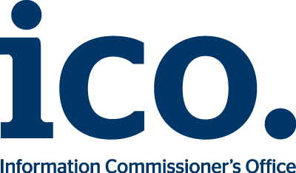
Changes to qualified trust service form
If you have made changes or are planning to make changes to the way your qualified trust service works you must fill in this form to let us know. We will then contact you about the next steps. It may be necessary for you to undergo another conformity assessment depending on the extent of the changes.
Your organisation’s name:
Your ICO reference (this should start eIDAS _xxx) :
What date has or will your qualified trust service change?:

Please provide a brief explanation of the changes you have made or are making:

Who should we contact?
Name:
Job title:
Phone:
Email:

Please send your completed form to audit@ico.org.uk.

