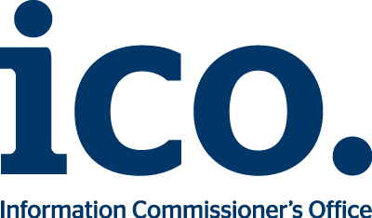

Notification of qualified trust service form

If you intend to provide a qualified trust service under the eIDAS regulation you must notify the ICO by filling out this form.
Who should we contact?
We will be in touch shortly after receiving your notification form to confirm receipt and inform you of the next steps.
Name:
Job title:
Phone:
Email:
Organisation name:
Which type of qualified trust service do you want to provide?
Select a trust service type from the list
The conformity assessment body
Please provide details about the conformity assessment body that carried out the conformity assessment.
Conformity assessment body’s name:
Main contact:
Phone:
Email:

Please confirm that the conformity assessment body has been accredited by the UK National Accreditation Body (UKAS) as competent to carry out conformity assessments under the eIDAS regulation.
Conformity assessment report and supporting evidence
In order for us to verify that you meet the requirements for the qualified trust service, please send us a copy of the following:
- your conformity assessment report;
- your information security breach management policy
- your information security policy; and
- your termination plan
Please send your completed form along with your conformity assessment report and supporting evidence to audit@ico.org.uk. On receipt of the report we will also ask for at least two further pieces of evidence.

